
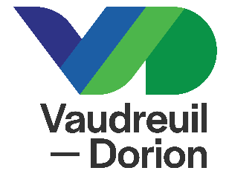

REQUEST FORM

Aide aux commerces en contexte d’entraves et services perturbés (ACCES)



For Développement Vaudreuil-Soulanges (DEV) to process your request, ensure to provide all required documents (see Required Documents’ section). These documents are necessary for a good understanding of your needs and ensuring that customers receive the best possible support.
Once the file is received, an advisor from Business Services will contact you at the earliest opportunity.
DEV informs you that the information collected on this form and any information that could be added to your file in the future, will be treated confidentially and will only be shared with those assigned to the decision-making process of your file.
Are you a client of DEV?

☐ Yes. Please write the name of your advisor:
☐ No

REQUEST FORM

Company Information
Name : |  | NEQ :
Address :
City : Vaudreuil-Dorion |  |  |  | Postal Code :
Contact : |  |  | Phone : -
Cell. : - | Email :

Primary Sector
☐ Retail
☐ Restaurant and food services
☐ Industrial company

Estimated amount needed
Amount: $
The assistance provided remains under DEV's discretion following the analysis of the information provided.

Required Documents
Please provide :
- Financial statements for the past two years (income statement and balance sheet)
- Most recent interim cumulative financial statements (max. 3 months)
- Proof of the building's occupation (lease or other)
- Certificate of use or acquired right

ACKNOWLEDGEMENT

I certify that the information contained herein, and the attached documents are, to my knowledge, true and complete.
The documents submitted by the applicant remain Développement Vaudreuil-Soulanges' property, who will ensure its confidentiality. However, the applicant authorizes DEV to exchange with those assigned and involved in the decision-making process of the file, including with the financial institution, all the information or documents necessary to assess this application. The applicant relieves members of the Vaudreuil-Dorion City Council and advisors of any possible liability that may incur by their decision and recommendation.

Click or tap here to enter a date _____________________________
YYYY-MM-DD Applicant’s Signature Name (please print)

IMPORTANT

Please send your form duly completed to ngagnon@developpementvs.com and ensure all required documents are attached.

